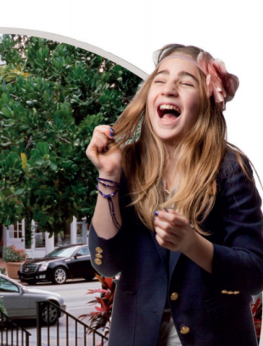
Task 1. Listen to the track https://cloud.mail.ru/public/4ghp/SRW4XR3Ce and work with a partner. Ask and answer questions about Ivy and your partner.
- complete the chart for Ivy
- complete the chart for your partner

Can…..? | Ivy | Your partner
speak a foreign language
cook
skateboard
swim
play tennis
ski
play any musical instruments

Task 2. Study the adverbs in the box.
(not) at all a little bit really well
very well quite well brilliantly

- Put the adverbs in the line from 0 (zero) to 100%

0% |  |  |  |  |  |  | 100%

- Complete the sentences about Ivy using the adverbs from the box:

(not) at all (x2) very well a little bit (x2) quite well really well brilliantly

- She can speak Spanish __________________.
- She can’t cook ______________________.
- She can swim _______________________.
- She can play tennis ______________________.
- She can ski _____________________________.
- Her Dad can play the guitar _____________________.
- Her Mom can play the piano _____________________.
- She can’t play anything __________________________.
Listen and check your answers https://cloud.mail.ru/public/4hiF/3HqggfftY

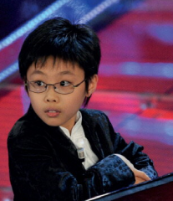
Task 3. Listen and complete the sentences about Marc Yu https://cloud.mail.ru/public/2FGt/3pkQMKDYt
He was born on January______ in 19_____ in California, USA.
He _______ _________ the piano and the cello.
He _______ _________ the piano when he _______ ________.
He _______ _________ the cello when he _______ ________.
Last year he played with Lang Lang, the famous Chinese pianist, in New York. They ______ a big success.

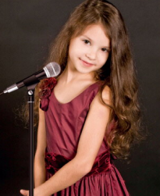
Task 4. Make the sentences about Cleopatra Stratan.
She ……. born…….. October 7th, 2002, …… Moldova near Romania.
She ……. sing beautifully when she ……. just two years old.
When she …… three, she made an album, La varsta de trei ani.
Her album …… a big success.
150,000 copies …… sold round the world.
Listen and check. https://cloud.mail.ru/public/3x7j/4yQrorSnE

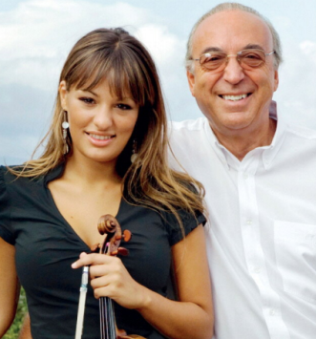
Task 5. Read the text A Passion for Success (p.42-43)
- Who or what do these adjectives refer to in the text?

busy |  |  | difficult
hard-working |  |  | expensive
poor |  |  | independent
important |  |  | proud
classical |  |  | passionate
close |  |  | sentimental

- State whether the sentences are true or false

No. | Sentence | True | False
1 | Nicola Benedetti is 32.
2 | Her sister’s name is Francesca.
3 | Nicola lives in Scotland.
4 | Nicola was born in 2004.
5 | Nicola started playing the violin when she was four.
6 | Nicola likes earning lots of money.
7 | At Christmas Nicola and her sister play together.
8 | Her father bought a Jaguar when he was 19.
9 | Gio is very independent.
10 | Nicola is of Italian origin.
11 | Gio doesn’t play a musical instrument.
12 | Her father likes classical music.

Task 6. Make questions about a famous person.
- When / born?
- Where / born?
- Where / live?
- Married?
- Have a family?
- What / children’s names?
- What / do?
- When / become famous?
- What / like doing?
- Where / like going to at weekends?

